# DMS Home Page (Manage Views)

## Infor:

1. Info of the current login user, current project

## Features:

1. This function is remove
2. Show list function in the menu

Return to DMS homepage

Add new Defect (add new defect page)

This function is remove

A report summary all the defect in the chosen project (Project summary page)

Import Defects from an exported file (Import defect page)

1. Log out
2. Choose project to view it’s defect (The project list base on the project that the login user joined)
3. Show status of the viewing project
4. Show all defects in this project (All defects view page)
5. Show all open defects in this project (All open defects view page)
6. Show all leakage defects in this project (All leakage defect view page)
7. Use to add user’s query (Add query page)
8. Delete user’s query

# Add new Defect Page

Use to add new defect

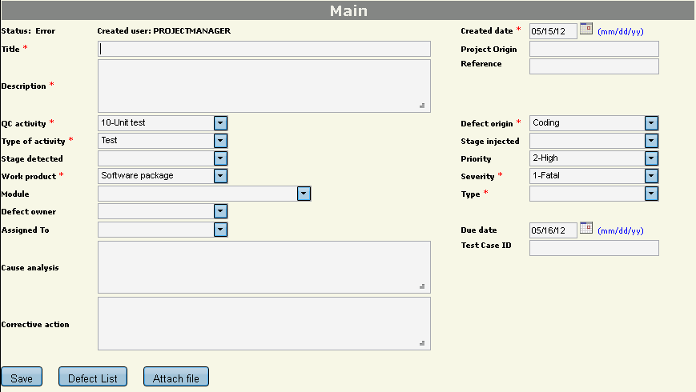

# Project summary Page

Summary defect of the project

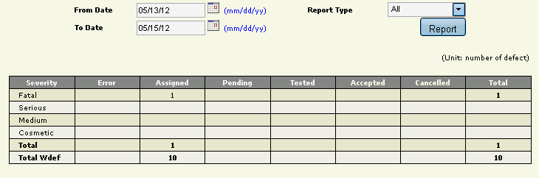

# Import Defect Page

Use to import defect from a file

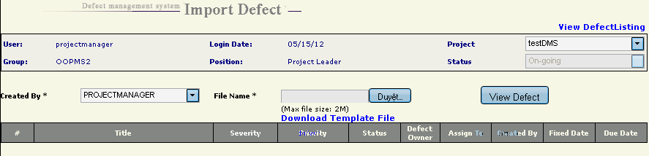

# All Defects view Page

View all defect in the project

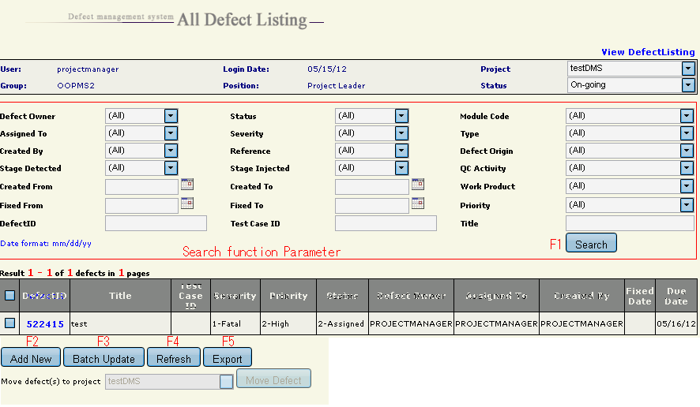

Features:

1 Search defects base on the parameter that set in “Search function Parameter”

2 Add new defect

3 Update a list of chosen defects at the same time

4 Search again

5 Export all chosen defects.

# All Open Defects view Page

The same as “all defect view page”

# All Leakage Defects view Page

The same as “all defect view page”

# Add Query Page

